Sum-Meet
Use Case Specification

Submitted to:

Asst. Prof. Ma. Rowena C. Solamo
Faculty Member
Department of Computer Science
College of Engineering
University of the Philippines, Diliman

Submitted by:
Batula, Bryce Spencer
Bayuga, Michael John
Yap, John Theodore

In partial fulfillment of academic requirements
for the course
CS 191 Software Engineering I
of the
1st Semester, AY 2015-2016
Unique Reference:
The documents are stored in https://github.com/trackertech568/CS191-Batula-Bayuga-Yap.
[File Reference in GitHub, preferably link.]

Document Purpose:
To show the flow of events of a use-case from its diagram.

Target Audience:
Meeting organizers.

Revision Control

History Revision:
Revision Date | Person Responsible | Version  Number | Modification
09/18/15 | Batula, Bryce  Bayuga, Michael  Yap, John Theodore | 1.0 | Initial Document; Version number should match the one found in the footer.

Use-Case Name: 6.0 Update Contact Info (Edit App)

Description: Once the meeting organizer adds the list of attendees, the system will search for their contact information from the tablet. If there is none then the system will ask the meeting organizer for their cellphone numbers and/or e-mail address.

Preconditions: If the system didn’t find the contact information of an attendee, it will ask the meeting organizer for it. Else if the meeting organizer wants to change the contact information then he/she can still update it.

Flow of Events:
Scenario Name | Description
Scenario 1 (Basic Flow)  System didn’t find any contact information of the attendee. | 1. System will search the device for the contact details of the attendee.  2. If there is none, then system will ask the organizer for the number and the e-mail address of the attendee.  3. Meeting organizer will input the cellphone number and e-mail address of the attendee.  4. System will update contact information of the attendee.
Scenario 2  Meeting organizer will edit the contact information | 1. Meeting organizer will input the cellphone number and e-mail address of the attendee.  2. System will update contact information of the attendee.

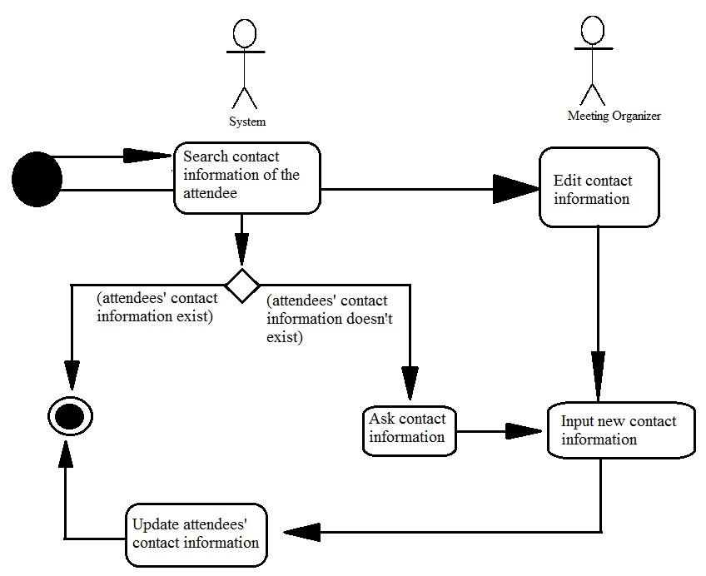
Activity Diagram of the Flow of Events:

Postcondition: NONE

Relationships: NONE

Special Requirements: NONE

